Published 01.11.2012

Reviewed 25.04.2023
Clinical Safety Case Report Interweave Portal
Interweave Care Portal

Document filename: CSCR Interweave
Directorate / Programme | IC Portal | Project Interweave
Document Reference CSCR IC Portal
Director Lee Rickles |  | Status Complete
Owner Ian Clucas |  | Version 4.0
Author Rebecca Wilson  Amendments Paul Warwick |  | Version issue date | 25.04.2023

Document Management
Revision History
Version | Date | Summary of Changes
1.0 | 01.11.2012 | Created
2.0 | 10.01.2022 | Amendments to text
3.0 | 08.10.2022 | Inserted diagrams and org chart
4.0 | 25.04.2023 | Paragraph included relating to Contextual Launch (pg.11)
Reviewers
This document must be reviewed by the following people:
Reviewer name | Title / Responsibility | Date | Version
Ian Clucas | Product Manager Interweave | 25.04.2023 | 4.0
Robert Hickingbotham | CEO Synanetics |  | 4.0
Approved by
This document must be approved by the following people:
Name | Title | Date | Version
Lee Rickles | Programme Director |  | 4.0
Related Documents
These documents provide additional information and are specifically referenced within this document.
Ref | Document | Title | Version
1 | DCB 0129 - Clinical Risk Management: its Application in the Manufacture of Health IT Systems - Specification |  | 4.1
2 | DCB 0160 - Clinical Risk Management: its Application in the Deployment and Use of Health IT Systems - Specification |  | 3.1
3 | Hazard Log Interweave Portal | HL ICP V3.0 | 3.0
4 | Clinical Risk Management System | CRMS Humber | 0.2
5 | Clinical Rick Management Plan | CRMP draft | 1.0
6 | Service Management | YHCR Service Delivery Model Approach | n/a
7 | Standard Operating Procedure Clinical Safety Testing | SOP YHCR CS v0.2 draft | V0.2
8 | Interweave Care Portal Specification for users | Interweave Care Portal Specification of Requirements | V1.1
9 | Test Approach and Strategy | Interweave Production Environment Clinical Safety Testing Approach | tbc
10 | Data standards | FHIR.INTERWEAVE\Home - FHIR v3.0.2 (interweavedigital.com) | n/a

Contents
Document Control 5
Intended Audience 5
Executive Report 5
Background 5
Introduction 6
System Definition / Overview 7
GP Connect 11
Onboarding Assurance Quality Gate Process 11
Governance 13
Roles and Responsibility 13
Clinical Risk Management System 14
Clinical Risk Analysis 15
Clinical Risk Control 16
Hazard Log 17
Service Management & Incident Reporting 19
Test Strategy 20
Training 21
Quality Assurance and Document Approval 21
Configuration Control / Management 21
Safety Summary Statement 22
Recommendations 22
Appendices 24
Appendix 1 24
Appendix 2 25
Appendix 3 25
Appendix 4 25
Appendix 5 26
Glossary of Terms 26

Glossary of Acronyms
Clinical Risk Management System | CRMS
Application Programming Interfaces | API
Clinical Risk Management | CRM
Clinical Risk Management File | CRMF
Clinical Risk Management Plan | CRMP
Clinical Safety Case Report | CSCR
Data Co-ordination Board | DCB
DCB 0129 | Clinical Safety Standard- Clinical Risk Management: its application in the manufacture of Health IT Systems
DCB 0160 | Clinical Safety Standard- Clinical Risk Management: its application in the Deployment and Use of Health IT Systems
Electronic Patient Record | EPR
Google Identity Provider | GIP
Integrated Care System | ICS
Integrated Care Board | ICB
Interweave Care Portal | ICP
Hazard Log | HL
Patient Demographic Service | PDS
Legitimate Relationship | LR
SystmOne | S1
Shared Care Record | ShCR
User Interface | UI
Data Quality Report | DQR
Patient Demographic Service | PDS
User Acceptance Testing | UAT
Change Advisory Board | CAB
Structured What If Technique | SWIFT

Document Control
This document is available in two forms, controlled and uncontrolled. The controlled variant is maintained electronically and accessed by authorised persons of the Interweave team. Uncontrolled variants are all other electronic and printed copies. The author of this document is Rebecca Wilson appointed Clinical Safety Officer. GPHC:5027499.

Intended Audience
This document will be made available to all key stakeholders involved in the design, test and implementation of the IEP product in order to inform their own clinical risk management activities. Where Interweave deploy the product to a Healthcare Organisation or site this document, along with the Hazard Log will be shared. The deployer of the IEP are responsible to comply with the mandated clinical safety standard DCB0160-Clinical Risk Management: its Application in the Deployment and Use of Health IT Systems.

Executive Report
This report is written in support of the Interweave Exchange Portal (ICP) product, it seeks to meet the requirements of the mandated clinical safety standards specifically the DCB0129- Clinical Risk Management: it’s Application in the Manufacture of Health IT Systems.
This document relates to the functions, capabilities and manufacturer of the IEP product developed by the original Yorkshire and Humber shared Care Record (YHCR) programme and manufacturer by Synanetics (middleware).

Background
In the UK, manufacturers of health IT systems including software are required to comply with the clinical safety standard DCB0129- Clinical Risk Management: its Application in the Manufacture of Health IT Systems (Ref 1). The standard sets out a framework for clinical safety activities, therefore rigorous and systematic analysis must be completed by any company wishing to provide their product(s) to the market. The technologies which are to be used in the health and social care settings which involve patient information and/or decision making must be evaluated to ensure there is no increase to patient harm. Evaluation must be performed to establish the nature of any potential clinical hazards and the degree of clinical risk that might be introduced.
The Clinical Safety Objectives for this product are:
- Throughout the development and deployment of the ICP product it has continued monitoring of the hazard assessment and Hazard Log
- The ICP product is clinically safe in the context of its intended purpose or use
- To monitor any change to the product, assess any potential risk and mitigate these
- Identify and assess clinical hazards and risks to ensure patient safety
- Identify safety critical functionality of the product and evidence assurance activities in these areas to mitigate clinical risk

Introduction
Synanetics together with the historic YHCR have developed core components to enable the sharing of health and social care data. These include:
InterWeave Exchange – an open standards data platform featuring FHIR aggregation, messaging, terminology management, consent and access management, record location, master patient index etc.
InterWeave Care Portal – a configurable and extensible Shared Care Record presentation layer
InterWeave Connect – highly performant and scalable FHIR Integration Engine and FHIR Store
As the need for the shared care records have developed the regional Integrated Care Services (ICS) are now funding the Interweave work collaboratively with the programme team to ensure deliverance of core components within the regions. These include: Humber, Coast & Vale, West Yorkshire & Harrogate, South Yorkshire & Bassetlaw, Leicester, Leicestershire and Rutland, Nottinghamshire.
The concept behind the Interweave products are for the patient to be at the centre, with the potential of various health care sectors plugging into the Interweave Care Portal to gain a picture of the patients health and social care data at the time. The ICP has been developed to provide the ability to enable appropriate and effective sharing of information for direct care purposes, through the interoperability of current health and care record systems, to facilitate improved outcomes for patient and service users. Access to the ICP is for the purposes of direct care by those who have a legitimate relationship with the patient or service user.
As the programme evolves more and more data providers contribute their data into the Interweave Exchange and this is consumed by a number of other organisations either using their own User Interface or the Interweave Care Portal.

Historically, consumers of data would create their own User Interface (UI) to display the data provided into the exchange, this can still be an option however, the portal was developed to aid those which were not able to develop their own UI. The original use cases for the portal were organisations where local source systems could not be modified to connect to the Exchange, or in some instances there may be no local system at all. So that such organisations are not excluded from the value of being able to view health and care data, the portal was developed. As the portal has developed it became apparent that it could be used by other consumers wishing to adopt a user friendly easy to understand portal. The Interweave Portal can be used as a ‘viewer’ into the data within the Exchange providing users with the available data at that time.
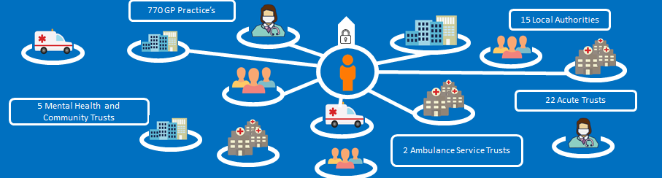
Example of how the portal can be used in an ICS

System Definition / Overview
The ICP is mainly web hosted, it uses simple panel design and structure to display data provided by a number of on-boarded sites. The portal can be opened in TPP’s context launch with ongoing developments with EMIS emerging.
The Portal is a standalone multi-tenant web-app, hosted within the same cloud instance as the Exchange, which provides a blended view of the data aggregated by the Exchange, and thereby provides a holistic view of the patient. Data is currently presented using panels to show information for specific FHIR resources, as well as demographics validated against national NHS services, and unstructured data such as documents. It is important to note that only data which is provided by the providing sites is available. Providers do provide various data resources with various timeframe limitations, therefore not all the available data for the patient may be shared into the exchange. Users are made aware of this on logging in with the portal disclaimer.
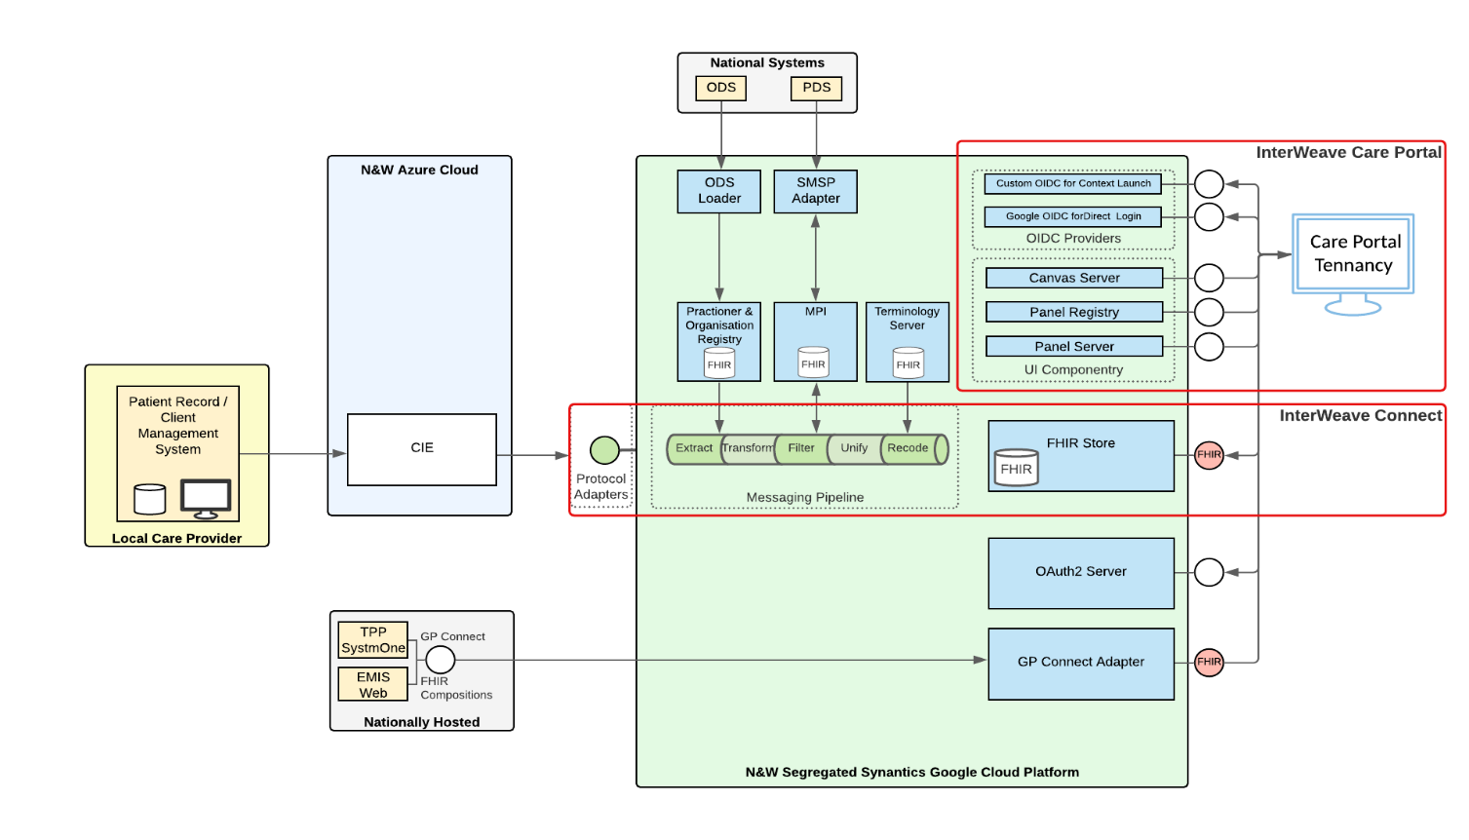
The above diagram shows the portal infrastructure.

Login security
In standalone mode, the system employs multi-factor authentication via Google Identity Provider (GIP). This requires the user to log their mobile phone number against their user account so that the system can generate a unique code to be sent to the phone via SMS, this code is required before the user is granted access to the system.

Operating models
In addition to standalone mode, Portal panels can also be accessed by other applications via integration, and is capable of a contextual launch where appropriate, e.g. presenting data from the Exchange directly from a patient record in GP systems such as TPP SystmOne.

The Portal is an evolving product as the programme learn about usability during testing with health and care workers, currently the data resources which are available includes:

- Appointments
- Allergies
- Encounters
- Episode of Care
- Documents
- Medications
- Related Persons
- Tasks
- Referrals
- Procedures
- Conditions
- Flags
Future data resources will be available, these include but is not exhaustive of:
- Observations and Results
- End of Life Care plans
- Diagnostic Report

In addition to the resources been provide by provider sites, the Portal also displays GP Connect HTML data directly from NHSD.
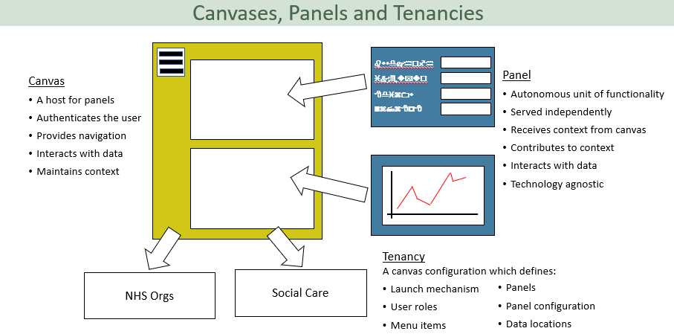

The above diagram shows the design of the portal panels, these can be configured by the end organisation via an admin account. Some of the data fields will be mandatory, for instance the medication panel is less configurable. This is because the panels have been designed with users, clinicians, Clinical Safety Officers and the design team to ensure the panels are showing relevant, important information which should not be excluded or missed.

Originally version 1 of the portal was developed for a proof-of-concept purpose, as it developed version 2 panels have now been designed and released. Once the user has logged in, there are presented with the disclaimer, a patient search screen is presented here, a user can search using the patients NHS number or first name, last name and DOB. Once the patient is found using the Patient Demographic Service (PDS) a legitimate relationship (LR) screen appears. The user must confirm their have a LR with each patient before being granted access to the patients record.
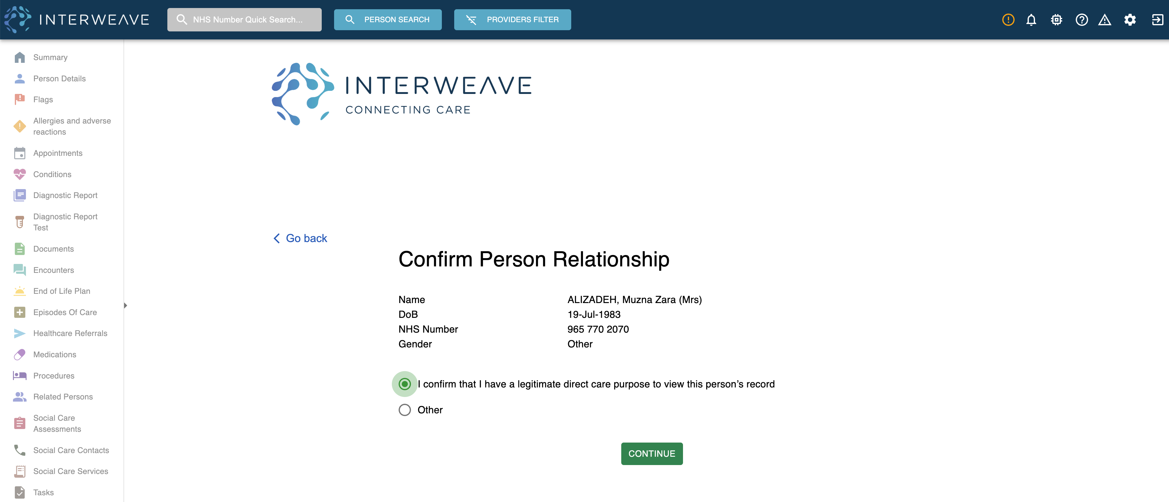

The portal opens on a summary screen, this provides a quick overview of the data available for the patient at that time from the providers. There is a filter to show which organisations are providing data. There is also a data available feature so the end users can clearly see which data resources are provided by the provider, together with a data supply.
Each panel displays a number to show the amount of data available within the resource, these can be expanded to show further information via drill down user interfaces. Alternatively, the user can click on the resource header in the left navigation column. Data is aggregated on the summary panels, which means the portal uses smart technology to analyse the data provided from various providers and if it is the same it will aggregate it and display it once rather than multiple times. However, there is an option to click into this information so the data providers can be identified. Aside from the panels the demographic banner is shown on every screen along with alert tabs for important information such as Flags, Allergies and if an End of Life Plan exists.

The app bar at the top of the screen shows a warning icon, this can be used to show if any data impairments or errors are found.
.
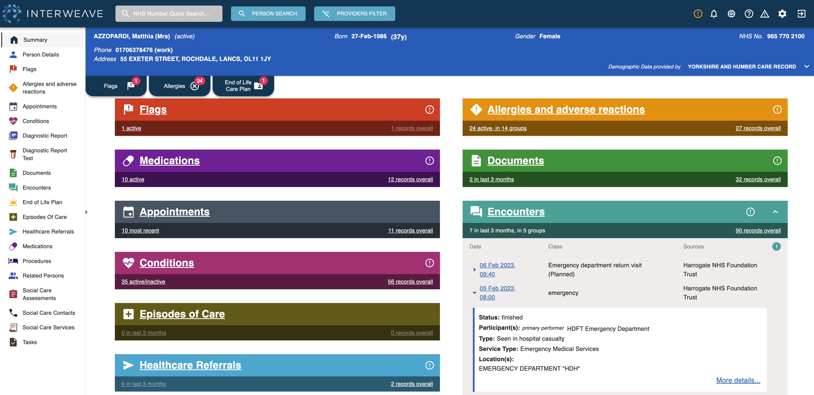

The above shows a view of the summary page. A data standards specification is currently being developed by the team, this is ongoing work which is looking at each FHIR resource and providing the providers with a standard framework to use in the provision of data. As this is implemented over time more structured data provision will emerge and therefore be available consistently across the portal.
Launch in Context
In line with the operational models mention previously, the Portal support contextual launch, allowing users to open the portal from within an external application, for example within TPP Systmone or EMIS Web.
When a user is in the electronic patient record (EPR) they can launch the Interweave Integrated Care Portal as prescribed by individual EPR systems, generally an option from within the patient record. The portal will launch within a browser and pull through the record of the identified patient. The user can then review the additional information contained within the portal, i.e., the data being provided by other health and care organisations.
Once finished, the user should log out and close the tab. However, it is recognised this may not always be the case in daily practice. If the user goes back into the EPR and repeats the actions for a different patient, another tab is opened for that patient, and whilst the existing tab may still be open, the portal will have recognised the user has opened another patient record and close the previous record down.
The function to search for multiple patients within the portal does not exist in the contextual launch mode, this is to reduce the likelihood of different patient records been opened at one time.

GP Connect
GP Connect has worked with GP clinical system suppliers to develop Application Programming Interfaces (APIs).
These APIs make data from clinical systems available in a standard form so that it can be used across different systems and be made available to clinicians who need access to the data for direct patient care.
Currently the information been shared is:
- Access Record: HTML which allows clinicians to view a read-only version of the patient’s detailed GP practice record
- Appointment Management which allows organisations to share and manage their appointments to support joined up patient care
Initially the Interweave programme has focussed on connecting GP connect into the Exchange using an adapter, the programme team have worked closely with NHS Digital to assure the safe and effective use and transfer of data using the API specifications. Vigorous testing has been completed and the clinical hazards reviewed by the clinical safety officer (CSO). The integration of GP Connect into the Exchange allows the on boarding sites to receive and view the HTML text. The Interweave Portal has been assured for consumption by NHS Digital, therefore all consuming deployers of the portal are not required to comply with their individual assurance through NHS Digital. If however, a consumer wishes to consume GPC through their own user Interface the SCAL process must be completed. Currently the GPC data can be accessed via the left-hand navigation panel. It is important for the user to understand that this is currently in a separate tab to the other data provision. This is because the ICP must display the data as it is received from NHS Digital. It cannot be aggregated or placed with the other data resources at this time. Users should therefore view the GPC data tab in parallel to the other data which is available.

Onboarding Assurance Quality Gate Process
The Interweave programme has an Onboarding Assurance Quality Gate Process. These processes contain several clinical assurance gateways to ensure the data been provided is safe for consumption. Any onboarding site wishing to provide data will be expected to produce a Data Quality Report (DQR). This document is created by the individual organisations and details the FHIR resources provided, identifies any impairments, evidences the testing (completed in UAT) and has clinical/leadership sign off. The DQR report should be updated at each iteration from Sandpit through to Production where applicable. The data flowing into the Exchange is analysed, evaluated and assured. Detail of the clinical activities are detailed below:
- Clinical Safety Scope Assessment - Individual organisations providing data should perform a CS scope assessment with the technical and project team to ensure the data being provided is clinically safe and accurate, additional hazards should also be identified at this stage. This would feed into the Data Quality Report.
- Clinical Safety Assessment – Individual organisations consuming the data from the YHCR should complete their own clinical safety testing and assessment to ensure the consumed and deployed data to users is clinical safe and local processes evaluated in line with their own DCB0160 responsibilities.
- Clinical Safety Assurance is provided by the YHCR once the Data Quality Report has been reviewed by the Clinical Safety Officer (CSO). This will be completed at each stage from Sandpit through to Production where highlighted on the process maps. Clinical Safety Assurance should also be completed by the consumers CSO or responsible person reviewing the end user acceptance testing.
- Clinical Safety Smoke Testing is completed by the individual organisations in the production environment once the data has been provided or is being consumed. A selection of live data should be tested to ensure accuracy. The clinical or appointed lead should complete this, this feeds into the Data Quality Report and/or the DCB0160 responsibilities as detailed on the process maps.
- DCB0160 Clinical Safety Standard is the consumers responsibility, a Hazard Log and Clinical Safety Case Report should be held in relation to the deployment of the Interweave portal.
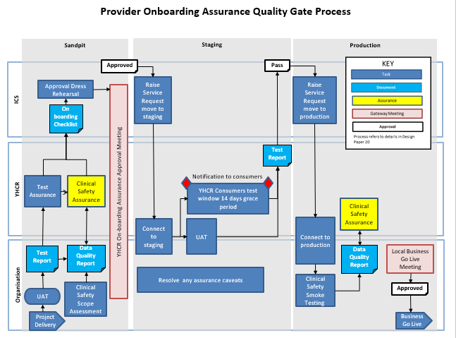

The data flowing through the Exchange to the portal is assured using the above process. The individual organisations complete their own testing and assurance as part of their responsibilities of the clinical safety standard DCB0160. The data consumed can be viewed in the Interweave Portal. It is the responsibility of the consumer to test and assure the data and ensure it is displayed in the user interface accurately before deployment.

Governance
The Interweave programme has a governance framework in place, this consists of a wide range of responsible people which form a series of groups and forums. These include but are not exhaustive:
- Weekly team meeting which brings all the programme together with a set agenda to discuss progress etc.
- Change Advisory Board (CAB) bi-weekly meeting to discuss any development’s, releases and approvals
- Clinical & Technical Design Authority Group with occurs every two months and consists of a number of clinical, non-clinical and technical bodies from across the region. Discussions are held within this group about current work and future proposal’s, this is led by the Clinical Lead.
- Daily stand-up calls with the test manager and select members of the programme team as well as Synanetics the current middleware developers.
- Various SCRUM ceremonies (sprint planning, review, retrospectives) are held between programme team members and Synanetcis to plan and review work packages
- Integrated Care Systems (ICS) leads meet on an ad-hoc basis to discuss regional progress, plans etc, but this is evolving into a more formal Product Steering Group

Roles and Responsibility
Detailed below are the named personal responsibly for the Interweave products, assurance and ensuring that the clinical safety activities are completed:
Role | Name
Programme Director | Lee Rickles
Clinical Lead | Dr Jason Broch
Product Manager | Ian Clucas
Project Manager | Hollie Harrison
Project Manager | Adam Brown
Data standards manager | Sophie Lo(wsley
Test Manager | Kunle Sadare
Clinical Safety Officer | Paul Warwick
Lead Technical Architect (Synanetics) | Robert Hickinbotham
Head of Applications (Synanetics) | Emma Smith
Applications Developer (Synanetics) | Greg Kekesi
Senior Applications Developer (Synanetics) | Richard Brown

The Clinical Safety Officer will retain overall responsibility for the following activities:
- ensuring that clinical risk management activities are completed in accordance with the Clinical Risk Management System
- reviewing and approval of all safety documentation including Clinical Safety Case Reports and Hazard Logs
- reviewing of any evidence in the Clinical Risk Management File to ensure it is complete and supports the Clinical Safety Case Report
- providing recommendation to Top Management regarding whether the Health IT System in this case the ICP is safe to release and review future release’s
- raise any unacceptable safety risks to Top Management

The diagram below shows the organisation chart for the Interweave Team.
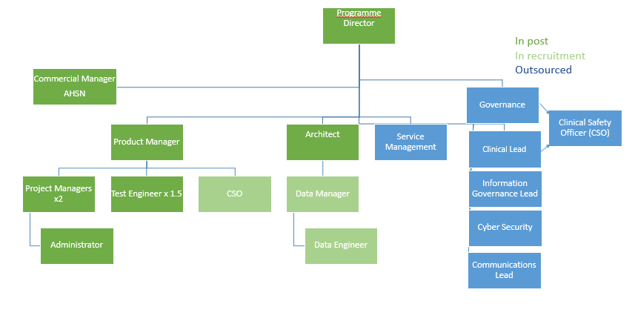

Clinical Risk Management System
The Interweave programme has a Clinical Risk Management System, a dedicated Clinical Safety Officer and Clinical Assurance Gateways as documented in the Onboarding Assurance quality Gate Process for data providers into the exchange. In terms of the Interweave portal the same CRMS is adhered to. Interweave has a clinical lead as well as other clinicians involved in the programme, the various CCIOs and clinical leads from onboarding sites across the region have formed a Clinical & Technical Design Authority group. The Clinical Risk Management System which applies to the Interweave product is currently held by NHS Humber Teaching Foundation Trust . The Clinical Risk Management activities conducted include the following areas:

- Risk management including:
- Risk Analysis
- Risk Evaluation
- Risk Control
- Clinical Hazard Identification including:
- Clinical Hazard workshops
- Hazard mitigation and control
- Hazard methodology
- Control Measure Implementation

Clinical Risk Analysis
The Hazard log included in this document outlines the hazards identified regarding the Interweave Care Portal, these have been scored and risks mitigated accordingly.
The data will inform clinical decisions therefore a thorough clinical safety assessment and review must be carried out at each site onboarding and deploying the portal. They are responsible for their own clinical testing, scenario building, training and guidance to end users, service management and incident reporting.
Any site wishing to on-board to the Exchange, or use the Portal, have and must pass various assurance gateways, some of these include but is not exhaustive of:

- Information Governance
- Cyber Security
- Technical Architecture
- Testing in Sandpit & Staging
- Clinical Assurance
The product team are involved in hazard identification through weekly/monthly/ad-hoc meetings and regularly liaise throughout the project lifecycle of the development and release. The people involved understand the product as well as being subject matter experts in their work-stream/field.
The clinical safety officer used Structured What If Technique (SWIFT) to enable identification, root cause analysis and apply some additional control recommendations for the ICP. It is recognised that not all controls may be practical for all and this report with the support of the hazard log should be used as guidance
The method used by the clinical safety officer to ensure the risk score was as low as possible is a principle, called the AFAP principle. See diagram below. The principle stands for “as far as possible” and its core is to look at the individual risk and assess how that may be controlled to reduce the likelihood of it occurring through applying mitigations. This principle aligns not only to DCB 0129 & DCB 0160 clinical safety standards, but also to the most recent publication of ISO standard for the risk management of medical devices (EN ISO 14971:2019).
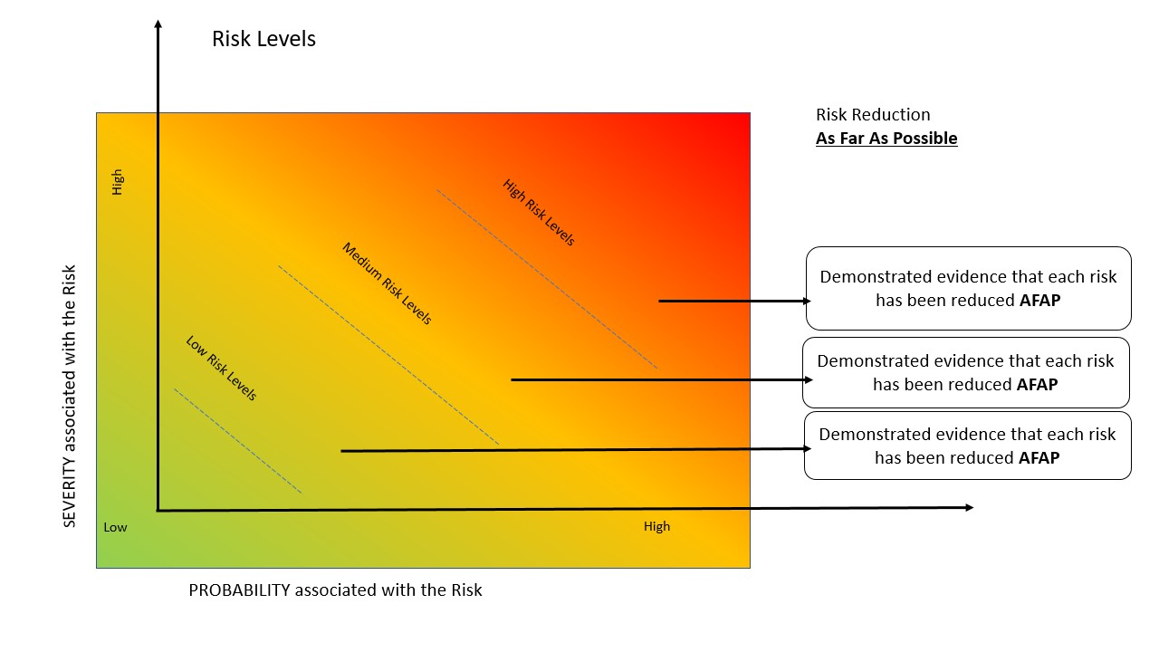

Clinical Risk Control
The Interweave programme has thorough clinical risk control. This includes regular hazard assessment, control revision, recommendations to end users. Issue and Incident management processes, users can raise tickets for any issues using JIRA, these are prioritised and actioned by the product team. Where applicable these are reviewed by the CSO.
A hazard log is held for the ICP and exchange any existing and new hazards are recorded and mitigated and where applicable disseminated to other sites via the ICS leads.
Workshops, meetings and forums will be held where necessary to identify, review and evaluate any existing or new risks. Users should be trained to ensure uniformity with portal usage.

Hazard Log
This includes the following components:
- Hazard identification
- Description of patient safety consequences
- Explanation of hazard causes and contributory conditions
- Identification of existing mitigating controls
- Estimation of clinical risk
- Identification of participating personnel
The Interweave team and Synanetics performed a hazard assessment which identified hazards, these have been scored using the NHS Digital Risk Matrix.
The hazards were scored and then the residual risk scored, these hazards are transferable between sites which are onboarded therefore once reviewed by the CSO and site the hazard should be reflected in their own hazard log and controls applied. Once the controls and mitigations are applied their individual residual risk should be lower than the initial risk score.
The Top Level Hazard: Users of Interweave inappropriately view data either intentionally or unintentionally which leads to a clinical decision

Resulting in: A clinical judgement being made on information presented

Effect: The user could base their decision and treatment on the information provided through the portal. Missing, Incorrect or conflicting information could lead to patient harm or even death if the presented results in a user acting up on it.

Hazard Groups:
Controls:
- Barrier sets:
  - Barrier Set 1: (DCB 0129) – Product Design, Training and Business Process safety controls
  - Barrier Set 2:( ( DCB 0160) – Deployed organisations mitigations
  - Barrier Set 3: - Local communications / guidance, monitoring and support functions for deployed organisations from ICS

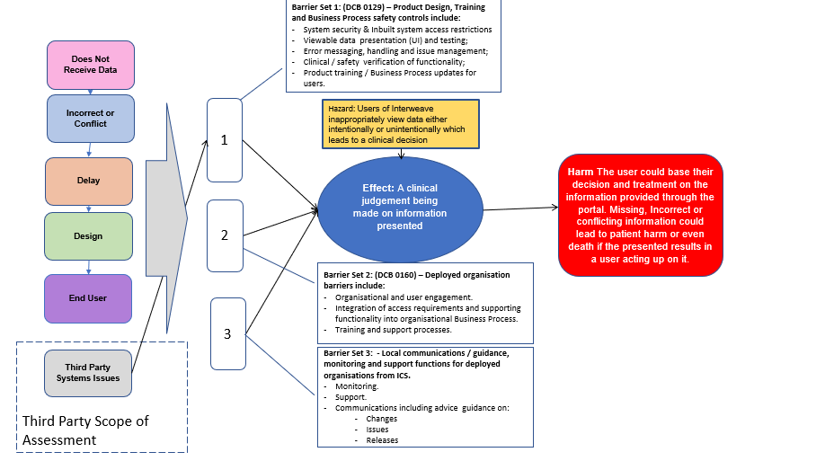

For the ICP 5 hazard groups have been identified, when individual hazards are identified these are then mapped to the hazard group. The diagram below shows this logic.
The five hazard groups are presented in the hazard log on the first tab, this provides the high level detail of the hazards, the initial controls and scores for each group. On the in-depth hazard tab more granular hazards are documented, these are mapped to the overarching hazard group. Further controls may be documented against these hazards and are specifically useful for each deploying site. The hazard log can be used to form a checklist for safe deployment from the additional recommendations section which can inform the residual risk rating. It is important to understand that the risk scores should be used as guidance along with this CSCR and clinical safety assessments should be completed by the deploying organisations as each care environment is different.
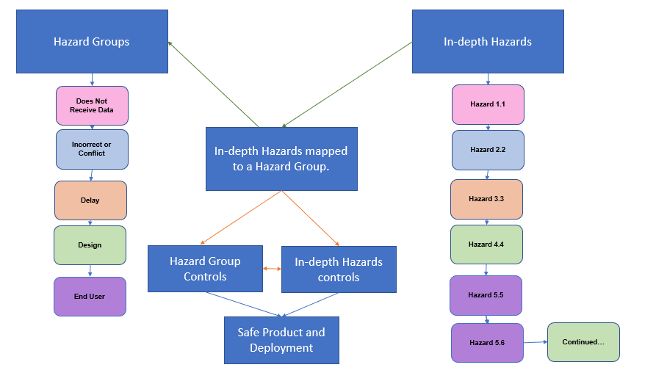

Service Management & Incident Reporting
Any incidents that arise from live service are triaged to local service desks and then on to the Interweave team, these incidents are actioned and other users informed via communication channels if affected. Incidents are logged at ICR Live Support - YHCR Service Desk (atlassian.net) . Clinical Safety related incidents are also recorded in Jira and scored accordingly. This then triggers an alert the CSO for review and action. Depending on the incident a number of actions may be taken, these include but are not exhaustive:
- A fix to be made to the product
- Investigation into the issue locally
- Investigation performed regionally
- Communication sent to all users who may be affected
- Review of incident at team meetings
- CSO review with other CSO’s in region
- Product team meet with developers
- Hazard log reviewed to ascertain if initially identified and review of controls
Details of the reporting process and incident management can be found in the support folder within Interweaves Teams folder.

Test Strategy
Exchange- The Interweave programme has a robust testing strategy and assigned test manager. In essence the test manager engages with the end users and performs a series of testing. These tests vary between providers depending on the data resource types been provided. Once User Acceptance Testing (UAT) has been completed a test report is produced which highlights any issues. These are reviewed and any issues agreed to be fixed and a timeline assigned. Daily/weekly calls are initiated between all parties to ensure durability and efficiently. Several further testing sessions may take place before the UAT is signed off. The UAT is performed in the sandpit environment. They may be occurrences when the issue log is reviewed by the CSO at this point to determine if an issue needs be fixed before moving on to the next stage. The test manager and CSO work closely together to identify, monitor and evaluate any issues and the testing. The data standards manager is also involved in the review of the testing to ensure the providing sites have aligned and mapped their data correctly to the FHIR resources and are complaint with the specification the Interweave programme team have developed.
Once in staging further tests are performed similar to that in the sandpit environment. No further issues should be detected at this stage however it can happen and therefore the test managers and CSO’s work together to ensure these are fixed and safe before proceeding. The test reports and Data Quality Reports are reviewed by the CSO and then a ‘Assurance Gateway’ meeting is scheduled with the organisations involved. Once approved and a date set the provider/consumer is connected to the Exchange. On the day further testing is performed by the CSO/Clinician/responsible person at the end site to ensure information is flowing correctly and safely in the production environment. After the initial one day assessment the service continues and is monitored in early life.
With regards to GP Connect robust testing has been driven by NHS Digital in the form of conformance testing. The test team have tested GP Connect as directed by the document set and provided evidence to the level directed by NHS Digital. This testing for the exchange provides assurance that the data displayed within the portal is assured and correct.

Portal- Designs and changes are discussed in sprint planning, these are then developed by Synanetics and reviewed at the sprint review meetings. This gives opportunity to identify any hazards and make comments or further changes. Once agreed the developments are released from the test environment into sandpit. These changes are tested by Synanetics then by the interweaves test manager and assured by the CSO. This occurs in each environment from sandpit, staging and through to production. If any issues are identified these are raised on tickets using JIRA. These are then actioned, fixes applied and retest completed before In pushing into live.

From a Synanetics developers perspective on testing:
- automated testing routines which run against units of functionality in the portal, written in a testing framework called Playwright (https://playwright.dev/)
  - This is limited by the quality (or lack thereof) of the static data currently available in sandpit – this will be improved when they get a static set of test records in a dedicated provider in the sandpit
  - This also functions as automated regression testing as it runs against all units of functionality at every deployment and we keep tests for all units of functionality
- The developers test their units of functionality as they are developing it
- code reviews where another developer will review the code written before a development branch is merged into what will be deployed
- run manual functional unit testing on new functionality (time permitting) at various stages in dev, test, sandpit, and staging
- run smoke tests after deployments on sandpit, staging and production in all environments

Training
Users guides and demonstrations are available for users, the interweave website also contains useful information for users. You tube videos are available giving a visual presentation of the portal and what to expect. It is advised that each deploying organisation and end user consumer is trained on the portal before use. Users some be familiar with what is provided into the portal, how it is presented and where to get help and support if required. The training should be completed and documented in the SOP for the deploying organisation.

Quality Assurance and Document Approval
The Interweave programme has a firm governance structure in place. Regular team meetings to review scope and raise risks and issues, work stream leads provide a fortnightly update. This group reports to the Delivery Board who assure the programme progress and action any risks and issues impacting on the programme delivery; this board has representatives from across the region from all ICS. The Delivery Board reports up to the Yorkshire and Humber Digital Care Board made up of senior executives from NHS and local government across the region.

Configuration Control / Management
Synanetics is responsible for the change and configuration controls and management as the middleware integrators. Any system changes or additional functions would still be passed through the Interweave programme team for agreement and approval. This is done so at the bi-weekly Change Advisory Board meetings. The clinical safety officer would also review and assure and changes/developments or new functions before release.

Safety Summary Statement
The Interweave Portal has been developed over the last couple of years by product specialists, developers from the middleware company and had oversight from clinicians, end users and Clinical Safety Officers. It provides a holistic view of patient data that is received through the Interweave exchange. Interweave exchange has its own assurance process for the assurance of data provision. This is detailed throughout this report. The build of the portal uses canvas and a panel design to easily capture and display the data retrieved. The portal has safety controls built in in terms of the disclaimer to the end users and data impairment warnings. It contains the data provider feed tab so users can identify which resources are available. Hover overs are available to give the users more details of what the icons means. Formatting has been taken into consideration and users are advised to use devices which can support the UI. Admin at deploying organisation have the choice to configure the panels with mandated restrictions still In place through Interweave. Reporting mechanisms are in place in terms of service desk support and reporting issues into JIRA for resolution. End user feedback is welcome to assist in the formation of the future of the portal. At each stage of the portal developments the CSO is involved in the design, test and deployment. The hazard log Is reviewed at each sprint review, development review, deployment and release as well as at any issues or incident reported. The CSO has an active role in the product governance. There are still some outstanding risks which are on the development cards for future, these include:
- Timeframe to be added to the data provider resource tab
- Allergies icon must be presented on each screen next to the flag icon
- GPC data to be easily displayed next to the other data provision to ensure it is not missed
The portal is continually assessed for safety and any downtime or issues found are communicated via email to the end users via the Rotherham support desk. In the near future a notifications feature will enable these alerts to be sent directly into the care portal. This CSCR and other supporting Clinical Safety documentation is reviewed and updated regularly. Although the portal is still progressing with developments it is a useful supporting tool for users to gain further information which would not normally be accessible. It provides useful information which may be considered for use in practice, however usual business processes and primary source systems should still be used to gain the full picture of the patient before any decisions are made.

Recommendations
- Users of ICP should review the disclaimer and any available user guides and training before use
- ICP should be used in addition to clinical practice and usual processes should be used to obtain the relevant information required
- It should be acknowledged the data available may not be all the data held for that patient from that provider at present
- Data impairments, conflicts and inconsistencies should be reported to ICP team
- Clinical users will use this as a tool and continue to document patient information within their own primary clinical system and patient medical records

- A Standard Operating Procedure should be developed and in place in each care setting which are using this product, this should include individual organisational/department process/workflows.

- A fall-back solution should be in place where the ICP product may not be able to be used

- Any organisation deploying the ICP products are responsible for the mandated Clinical Safety Standard DCB0160.

Appendices

Appendix 1

Hazard Consequence definitions
Consequence Classification | Interpretation | Number of Patients Affected
Catastrophic | Death | Multiple
 | Permanent life-changing incapacity and any condition for which the prognosis is death or permanent life-changing incapacity; severe injury or severe incapacity from which recovery is not expected in the short term | Multiple
Major | Death | Single
 | Permanent life-changing incapacity and any condition for which the prognosis is death or permanent life-changing incapacity; severe injury or severe incapacity from which recovery is not expected in the short term | Single
 | Severe injury or severe incapacity from which recovery is expected in the short term | Multiple
 | Severe psychological trauma | Multiple
Considerable | Severe injury or severe incapacity from which recovery is expected in the short term | Single
 | Severe psychological trauma | Single
 | Minor injury or injuries from which recovery is not expected in the short term. | Multiple
 | Significant psychological trauma. | Multiple
Significant | Minor injury or injuries from which recovery is not expected in the short term. | Single
 | Significant psychological trauma | Single
 | Minor injury from which recovery is expected in the short term | Multiple
 | Minor psychological upset; inconvenience | Multiple
Minor | Minor injury from which recovery is expected in the short term; minor psychological upset; inconvenience; any negligible severity | Single

Appendix 2
Likelihood Category | Interpretation
Very high | Certain or almost certain; highly likely to occur
High | Not certain but very possible; reasonably expected to occur in the majority of cases
Medium | Possible
Low | Could occur but in the great majority of occasions will not
Very low | Negligible or nearly negligible possibility of occurring

Appendix 3
Likelihood | Very High | 3 | 4 | 4 | 5 | 5
 | High | 2 | 3 | 3 | 4 | 5
 | Medium | 2 | 2 | 3 | 3 | 4
 | Low | 1 | 2 | 2 | 3 | 4
 | Very Low | 1 | 1 | 2 | 2 | 3
 |  | Minor | Significant | Considerable | Major | Catastrophic
 |  | Severity

Appendix 4

5 | Unacceptable level of risk
4 | Mandatory elimination of hazard or addition of control measure to reduce risk to an acceptable level
3 | Undesirable level of risk. Attempts should be made to eliminate the hazard or implement control measures to reduce risk to an acceptable level. Shall only be acceptable when further risk reduction is impractical
2 | Acceptable where cost of further reduction outweighs benefits gained or where further risk reduction is impractical
1 | Acceptable, no further action required

Appendix 5

Glossary of Terms
AFAP | As Far As Possible – The level risk acceptability criteria as per Clinical Safety Standards
Clinical Risk Analysis | Systematic use of available information to identify and estimate a clinical risk.
Clinical Risk Control | Process in which decisions are made and measures implemented by which clinical risks are reduced to, or maintained within, specified levels.
Clinical Risk Estimation | Process used to assign values to the severity (consequence) of harm to a patient and the likelihood (probability) of occurrence of that harm.
Clinical Risk Evaluation | Process of comparing a clinical risk against given risk criteria to determine the acceptability of the clinical risk.
Clinical Risk Management (CRM) | Systematic application of management policies, procedures, and practices to the tasks of analysing, evaluating, and controlling clinical risk.
Clinical Risk Management (CRM) Process | A set of interrelated or interacting activities, defined by the ETHOS Ltd. Clinical Safety Officers to meet the requirements of the DCB 0129 Standard with the objective of ensuring clinical safety in respect to the development, deployment and intended use of the Health IT System.
Clinical Safety | Freedom from unacceptable clinical risk to patients.
Clinical Safety Officer | NHS Digital accredited clinician responsible for ensuring the safety of the Health IT System through the application of clinical risk management as set-out in the NHS Digital DCB 0129 and DCB 0160 Standard requirements.
Clinical Safety Case Report (CSCR) | A report that presents the arguments and supporting evidence that provides a compelling, comprehensible, and valid case that the Health IT System is safe for intended use.
Digital Health Platform | A platform comprising hardware, software, and third-party components.
ETHOS Ltd. | Clinical Risk Management Health IT subject Matter Experts (Clinical Safety Engineers and Clinical Safety Officers) contracting to the Health Organisation, providing Health IT Clinical Safety assurance in respect of the Health IT System as set out in the NHS Digital DCB0129 and DCB 0160 Standard requirements.
Harm | Death, physical injury, psychological trauma and / or damage to the health or well-being of a patient.
Hazard | Potential source of harm to a patient.
Hazard Log | A mechanism for recording and communicating the on-going identification of hazards associated with the Health IT System.
Initial Clinical Risk | The clinical risk derived during clinical risk estimation.
International Organisation for Standards (ISO) | The organisation that develops and publishes International Standards.  Link at: https://www.iso.org/home.html
Intended Use | Use of the Health IT System in accordance with the specifications, instructions and information provided by the manufacturer to its clients for its intended use.
Likelihood (probability) | Measure of the occurrence of harm.
Manufacturer | Person or organisation with responsibility for the design, manufacture, packaging or labelling of a Health IT System, assembling a system, or adapting a Health IT System before it is placed on the market and/or put into service, regardless of whether these operations are carried out by that person or on that person's behalf by a third party.
Service User Safety | Freedom from harm to the patient.
Residual Clinical Risk | Clinical risk remaining after the application of risk control measures.
Severity (Consequence) | Measure of the possible consequences of a hazard.

