Clinical Safety Case Report Yorkshire & Humber Care Record System of Systems - Integrated Care

Yorkshire and Humber Care Record

Published 12/01/21

|  |  |  |  |
| --- | --- | --- | --- |
| Document filename: CSCR | | | |
| Directorate / Programme | Interweave | Project SofS – Integrated Care |  |
| Document Reference Clinical Safety | | 0129 | |
| Director Lee Rickles |  | Status Complete |  |
| Owner Ian Clucas |  | Version 5 |  |
| Authors Rebecca Wilson  Reviewed Paul Warwick |  | Version issue date | 12.02.2024 |

Document Management

Revision History

|  |  |  |
| --- | --- | --- |
| Version | Date | Summary of Changes |
| 1 | 23.10.2019 | Minor edits to text |
| 2 | 15.11.2019 | Reviewer added and Hazard log updated |
| 3 | 08.06.2020 | Report Amended to reflect SoS and Wave 1 report embedded, Hazard Log updated |
| 4 | 12.01.2021 | Report altered to form generic SOS CSCR and original report placed in appendix |
| 5 | 12.02.2024 | Updated branding and team role/membership |

Reviewers

This document must be reviewed by the following people:

|  |  |  |  |
| --- | --- | --- | --- |
| Reviewer name | Title / Responsibility | Date | Version |
| Dr Jason Broch | Clinical Lead YHCR | 2019 | 0.2 |
| Hannah McCann | NHS Digital Safety Engineer | 15/11/19 | 0.2 |

Approved by

This document must be approved by the following people:

|  |  |  |  |
| --- | --- | --- | --- |
| Name | Title | Date | Version |
| Rebecca Wilson | Clinical Safety Officer | 22/10/19 | 0.1 |
| Lee Rickles | YHCR Programme Director CIO | 24/10/19 | 0.2 |
| Lee Rickles | YHCR Programme Director CIO | 29/01/21 | 0.4 |

Related Documents

These documents provide additional information and are specifically referenced within this document.

| Ref |  | Title | Version |
| --- | --- | --- | --- |
| 1 | DCB 0129- Clinical Risk Management: its Application in the Manufacture of Health IT Systems | |  |
| 2 | DCB0160- Clinical Risk Management: its Application in the Deployment and Use of Health IT Systems | |  |
| 3 | YHCR Clinical Assurance Process | |  |
| 4 | SoS Hazard Log | |  |
| 5 | GP Connect Hazard Log (NHS Digital) | |  |

**Contents**

Contents

Glossary of Terms 5

Executive Report. 5

Introduction 5

System Definition / Overview 5

Messaging Types 6

Infrastructure 10

GP Connect………………………………………………………………………………………………10

YHCR Concept 10

Governance 11

Roles and Responsibility 11

Quality Assurance and Document Approval 12

Configuration Control / Management 12

Clinical Risk Management System 12

Clinical Risk Analysis 13

The Clinical Assurance Process ( ref 6 ) 14

Clinical Risk Control 14

Hazard Log 14

Technical/Cyber 17

Service Management & Incident Reporting 18

Test Strategy 18

Summary Safety Statement 20

Appendices 21

Appendix 1 21

Appendix 2 22

Appendix 3 22

Appendix 4 22

Appendix 5 23

## Glossary of Terms

|  |  |
| --- | --- |
| SoS | System of Systems |
| YHCR | Yorkshire & Humber Care Record |
| CSO | Clinical Safety Officer |
| DCB | Data Coordination Board |
| ICS | Integrated Care Services |
| LHCRE | Local Health & Care Record Exemplar programme |
| CAB | Change Advisory Board |
| CCIO | Chief Clinical Information Officer |
| ALARP | As Low As Reasonably Practicable |
| FHIR | Fast Healthcare Interoperability Resource |
| UAT | User Acceptance Testing |

# Executive Report.

# This report is written in support of the Yorkshire & Humber Care Record (YHCR) programme and it seeks to meet the requirements of DCB 0129 and the clinical safety standards. This provides guidance and protocol for on-boarding organisations connecting into the System of Systems (SoS) as well as users of the product. This is a working document and true at the time of constructing however this will change over time and be regularly updated.

# Introduction

The Yorkshire & Humber Care Record is the brand identity for a set of products and capabilities which are managed by the Yorkshire & Humber Care Record team. The development of these was instituted by the Local Health & Care Record Exemplar programme (LHCRE) under which NHS England/X awarded the Yorkshire and Humber region funding to improve interoperability between health care systems operating in the region. The number and scope of the products and capabilities is evolving but they are broadly aligned to:

* Improving access to care records in the provision of direct care
* Improving access to clinical and social care data for the purpose of population health management
* Engaging the citizen in their care, health and well-being.

At the core of the Yorkshire & Humber Care Record is the System of Systems (SoS)– a set of software components which facilitate secure access by data consumers to data held by data providers. In essence, the SoS is integration middleware. This Clinical Safety Report is only in relation to the SoS direct care work stream.

As the programme has developed the regional Integrated Care Services (ICS) are now funding the YHCR and work collaboratively with the programme team to ensure deliverance of core components within the region. These include: Humber, Coast & Vale ICS, West Yorkshire & Harrogate ICS and South Yorkshire & Bassetlaw ICS.

# System Definition / Overview

The System of Systems will be deployed in three distinct phases:

**Phase 1 – Rapid Star:** A minimum viable product, co-hosted with the Rotherham Trust Integration Engine, targeted at well defined, low volume, use cases involving a small number of participants.

**Phase 2 – Transitionar:** Functionally evolving product, hosted partially on a dedicated integration engine with migration to cloud based micro services, supporting the requirements of a growing number of participants.

**Phase 3 – Operation at Scale**: A functionally mature product, architected and hosted in the cloud, operating at high volume with participation from all major health & care organisations.

**Currently in Phase 2 of the deployment transitioning into Phase 3 at the time of writing this report.**

The SoS is being developed by the Yorkshire & Humber Care Record team using several third-party system integrators. The minimum viable product was developed by Synanetics Ltd under assurance from the Yorkshire and Humber Care Record Team.

In the future, different organisations may be awarded contracts to develop and maintain different components of the SoS and the product will have multiple manufacturers however Synanetics Ltd are the middleware integrators.

The Yorkshire & Humber Care Record team have worked with Synanetics to ensure that they comply with the clinical safety requirements DCB 0129 and this clinical assurance will be maintained by the various trusts onboarded into the SoS and there is a clear demarcation of responsibility between them for maintaining their hazard log and implementing the documented risk control and mitigation techniques in the future.

## Messaging Types

**Synchronous Query:** A data consumer requests data from the SoS, which services it in real-time from data providers, and issues the results over same connection on which the request was made. The method is explained further in the design paper for the [FHIR Aggregator](https://yhcr.org/wp-content/uploads/2019/07/YHCR_Design_Paper_010__FHIR_Aggregator_Service.docx).

Synchronous queries will typically be used by clinical software to access regional data in the context of a patient for the purpose of direct care. The data will inform a clinician of health and care providers’ contact with the patient outside of the care setting in which they operate. Data content will include:

* medications prescribed, stopped and administered;
* vital sign measurements;
* test orders and results including but not limited to: pathology, radiology endoscopy, audiology, and ophthalmology;
* problems and diagnoses;
* care plans;
* allergy Intolerances;
* clinical notes;
* historic encounters;
* appointments;
* demographics.

**Asynchronous Query:** A data consumer requests data from the SoS which acknowledges the request and drops the connection. The request is deferred to data providers which the SoS periodically polls and collects results as they are ready. The data consumer polls the SoS and ultimately collects an aggregated result set. The method is explained further in the design paper for the [FHIR Aggregator](https://yhcr.org/wp-content/uploads/2019/07/YHCR_Design_Paper_010__FHIR_Aggregator_Service.docx).



Asynchronous queries allow a data consumer to issue complex or high-volume queries to a data provider which cannot be serviced in real time. The asynchronous nature of the service means that it is not well suited to on-demand use and the service will be used primarily for acquiring data in bulk for subsequent processing. At the time of writing the only immediately foreseeable user of this service is the Population Health Management (PHM) platform. However, future uses for the purpose of direct care can be anticipated.

Use cases for population health management include:

* risk stratification;
* identification of correlations in condition development and treatment regime, socio-economic, lifestyle, and other factors;
* service planning.

Data content in query results could include:

* medications prescribed, stopped and administered;
* vital sign measurements;
* test orders and results including but not limited to pathology, radiology endoscopy, audiology and ophthalmology;
* problems and diagnoses;
* care plans;
* allergy Intolerances;
* clinical notes;
* historic encounters;
* appointments;
* demographics.

**Subscriptions:** A data consumer issues to the SoS a request for data which matches a search criterion. The request is deferred to data providers which send data, as they arise, to the SoS over a synchronous connection. The SoS passes on data that it receives to data consumers over a similar synchronous connection. Subscriptions continue to operate until they are cancelled. The method is explained further in the design paper for the [Subscriptions Infrastructure](https://yhcr.org/wp-content/uploads/2019/05/YHCR_Design_Paper_007__Subscriptions_Infrastructure.docx).



Subscriptions will typically be used by clinical software to notify care settings of an interest in categories of clinical events and for them to receive notification of occurrences of these events. Subscription will often, but not exclusively be in relation to a cohort of patients. Examples of these use cases could be:

* Alerting systems where clinicians are informed of subscription events for patients they treat;
* Dashboards displaying real-time statistics of how healthcare services are currently being used;
* Safeguarding;
* Algorithms monitoring trends in data points e.g. blood pressure / platelet count in order to promote intervention in care;
* Analytical tooling used for population health management and research purposes acquiring data required for study purposes.

Data content contained in the subscription notification could include:

* medications prescribed, stopped and administered;
* vital sign measurements;
* test orders and results including but not limited to pathology, radiology endoscopy, audiology and ophthalmology;
* problems and diagnoses;
* care plans;
* allergy andintolerances;
* clinical notes;
* historic encounters;
* appointments;
* demographics.

**Transactional Messaging:** A data provider uses the SoS s to deliver a transaction to a data consumer. Messaging is reliable in that the data consumer is required to issue an acknowledgement and the data provider will resend messages for which no acknowledgement is received. The method is explained further in the design paper for the [Reliable Messaging Infrastructure](https://yhcr.org/wp-content/uploads/2019/03/YHCR_Design_Paper_006__Reliable_Messaging_Infrastructure.docx).



Transactional messages will typically be used by care settings to exchange transactions representing clinical evens. Examples include:

* referrals of patients receiving cancer care between oncology centres;
* transfer of care from an ambulance to an emergency department;
* transfer of correspondence and / or between organisations.

The mechanism ensures guaranteed, secure delivery of valid messages between organisations.

Message content will include:

* patient demographics;
* appointment and encounter details;
* details of care provided;
* clinical observations and test results.

**The Asynchronous Query message type is currently used only for the population health management cohort of the YHCR and not directly used for the SoS direct care piece.**

## Infrastructure

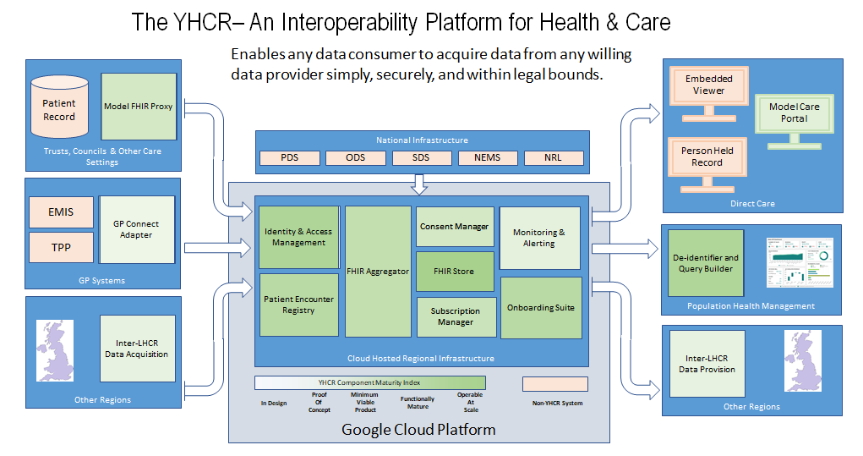

Currently the functionally evolving product, hosted partially on a dedicated integration engine with migration to cloud based micro services, supporting the requirements of a growing number of participants.



The above document details the data flows between data providers and consumers between the regional infrastructures.

## GP Connect

GP Connect has worked with GP clinical system suppliers to develop Application Programming Interfaces (APIs).

These APIs make data from clinical systems available in a standard form so that it can be used across different systems and be made available to clinicians who need access to the data for direct patient care.

Currently the information been shared is:

* Access Record: HTML which allows clinicians to view a read-only version of the patient’s detailed GP practice record
* Appointment Management which allows organisations to share and manage their appointments to support joined up patient care

Initially the YHCR programme is focussed on connecting GP connect into SoS using an adapter, the team has worked closely with NHS Digital to assure the safe and effective use and transfer of data using the API specification’s. Vigorous testing has been completed and the clinical hazards reviewed by the clinical safety officer (CSO). The integration of GP Connect into SoS allows the on boarding sites to receive and view the HTML text. It is important to note that each site which wishes to consume GP Connect will still be required to be assured by NHS Digital.

The partner organisations will be expected to consume data via the SoS endpoint and present this in HTML view in their own user interface. Therefore they will be required to perform some in house testing and complete the SCAL (Supplier Conformance Assessment List) process in accordance with the NHS Digitals standards.

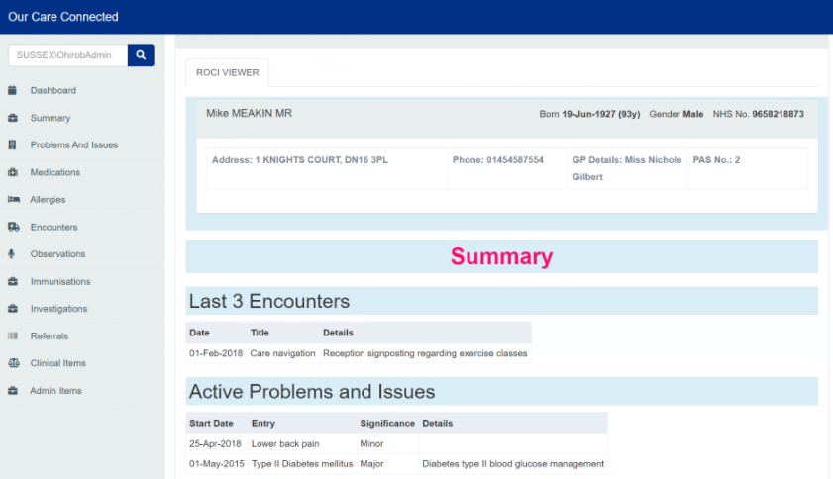

This is an example of how the HTML text will be presented to the consumer. (please note- not all data fields are visible )

## YHCR Concept

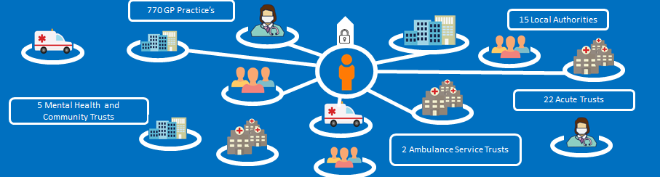

The above diagram shows the concept behind the YHCR Programme, the Patient been in the centre with the potential of various health care sectors plugging into the SoS product. Providers of data from various environment’s with a wide range of user’s - clinical, non-clinical and social care. As the programme evolves more and more data providers contribute their data into the SoS and eventually this is and/or will be consumed by a number of other users. This report relates to the providers and consumers of data through the SoS where by their own development teams work together with the YHCR to establish their own unique User interface within their primary source system to display the consumed information. Currently in development is the YHCR Portal which has its own Clinical Safety Report. The portal is a standalone web based User Interface which will be able to be accessed by users and view all data provided for their patients from all live data providers participating in the YHCR.

As outlined the number of data providers is growing and therefore clinical assurance is vital, the programme team work collaboratively with the test manager and Clinical Safety officer to ensure robust on-boarding, engagement, developments and testing are completed satisfactory.

## Governance

The YHCR programme has a governance framework in place, this consists of a wide range of responsible people which form a series of groups and forums. These include but are not exhaustive:

* Monthly YHCR team meeting which brings all the programme together with a set agenda to discuss progress etc.
* Change Advisory Board (CAB) bi-weekly meeting to discuss any development’s and releases and approvals
* Clinical & Technical Design Authority Group with occurs every two months and consists of a number of clinical, non-clinical and technical bodies from across the region. Discussions are held within this group about current work and future proposal’s, this is led by the Clinical Lead.
* Daily stand up calls with the test manager and select members of the programme team as well as Synanetics the current YHCR middleware developers.
* Various weekly meetings are held between programme team members to ensure alignment of work packages and assurance
* Integrated Care Systems (ICS) leads meet on an ad-hoc basis to discuss regional progress, plans etc.

## Roles and Responsibility

Detailed below are the named personal responsibly for the YHCR programme, assurance and ensuring that the clinical safety activities are completed :

| Role | Nomination |
| --- | --- |
| Programme Director | Lee Rickles |
| Product Manager | Ian Clucas |
| Role | Name |
| Programme Director | Lee Rickles |
| Clinical Lead | Dr Jason Broch |
| Product Manager | Ian Clucas |
| Project Manager | Hollie Harrison |
| Project Manager | Adam Brown |
| Data standards manager | Sophie Lowsley |
| Data Service Manager | Chintan Chokshi |
| Clinical Safety Officer | Paul Warwick |
| Lead Technical Architect (Synanetics) | Robert Hickinbotham |
| Head of Applications (Synanetics) | Emma Smith |
| Applications Developer (Synanetics) | Greg Kekesi |
| Senior Applications Developer (Synanetics) | Richard Brown |

The Clinical Safety Officer will retain overall responsibility for the following activities:

* ensure that clinical risk management activities are completed in accordance with the Clinical Risk Management System
* review and approval of all safety documentation including Clinical Safety Case Reports and Hazard Logs
* review of any evidence in the Clinical Risk Management File to ensure it is complete and supports the Clinical Safety Case Report
* provide recommendation to Top Management regarding whether the Health IT System in this case SoS is safe to release and review future release’s
* raise any unacceptable safety risks to Top Management

# Quality Assurance and Document Approval

The YHCR programme has a firm governance structure in place.  Regular team meetings to review scope and raise risks and issues, work stream leads provide a fortnightly update.  This group reports to the Delivery Board who assure the programme progress and action any risks and issues impacting on the programme delivery; this board has representatives from across the region from all ICS.  The Delivery Board reports up to the Yorkshire and Humber Digital Care Board made up of senior executives from NHS and local government across the region.

# Configuration Control / Management

Synanetics is responsible for the change and configuration controls and management as the middleware integrators. Any system changes or additional functions would still be passed through the YHCR programme team for agreement and approval. This is done so at the bi-weekly Change Advisory Board meetings. As shown in the clinical assurance process (Ref 3) the clinical safety officer would also review and assure and changes/developments or new functions before release.

# Clinical Risk Management System

The YHCR programme has a Clinical Risk Management System, a dedicated Clinical Safety Officer a Clinical Assurance Process. The YHCR has a clinical lead as well as other clinicians involved in the programme, the various CCIOs and clinical leads from onboarding sites across the region have formed a Clinical & Technical Design Authority group. The Clinical Risk Management System which applies to this YHCR programme is currently held by NHS Humber Teaching Foundation Trust . All on boarded sites that are onboarded or wish to onboard into the SoS would be required to submit their Hazard Log to the Clinical Safety Officer (CSO)so the master hazard log could be updated. This is to ensure visibility to all other sites which may be consuming their data. As hazards may be transferable it must be visible to enable other sites to consider the Hazards and mitigate accordingly. However the onboarding site are responsible for their own Clinical Safety Report which should include their own clinical risk management system and comply with the clinical safety standard DCB0160.

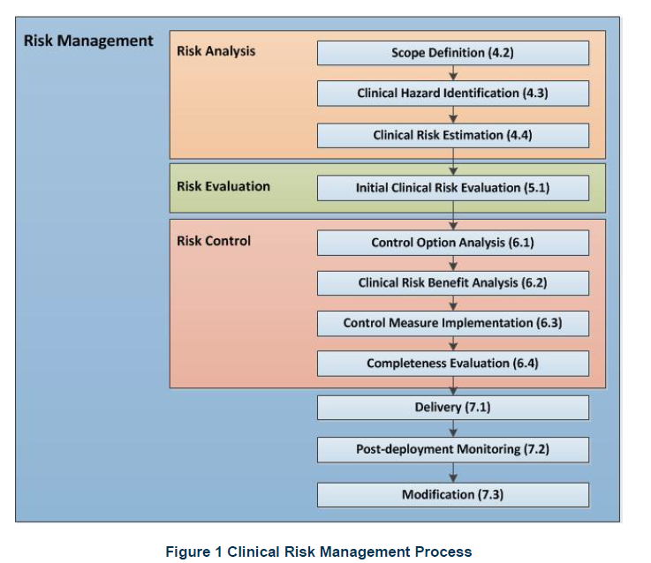

Above is the Clinical Management Framework YHCR uses in regards to their clinical risk management activities.

# Clinical Risk Analysis

The Hazard log included in this document (ref 4) outlines the hazards identified regarding the SoS product, these have been scored and risks mitigated accordingly. Please see the Hazard log section for any high risk identified hazards. This also includes some onboarded sites Hazard Logs and forms a master log.

The data will inform clinical decisions therefore a thorough clinical safety assessment and review must be carried out at each site onboarding. They are responsible for their own clinical testing, scenario building, training and guidance to end users, service management and incident reporting.

Any site wishing to on-board to the SoS have and must pass various assurance gateways, some of these include:

1. Information Governance
2. Cyber Security
3. Technical Architecture
4. Testing in Sandpit & Staging
5. Clinical Assurance Process

## The Clinical Assurance Process ( ref 3 )

The YHCR programme has a 2 stage Clinical Assurance Process. Any onboarding site wishing to provide data will be clinically assured, the data flowing into the SoS is analysed and evaluated. Once complete a report is generated and any issues found are reported to the providing site. This is stage 1 of the process. The 2nd stage is for the data flowing through the SoS to be checked at the consuming site. The CSO working for YHCR completes this assurance. However it is also the responsibility of the consumer to test and assure the data and ensure it is displayed in the user interface accurately. The CSO’s work together with the test teams and clinician’s to ensure the data is flowing correctly and most importantly the context and terminology are accurate. Any issues identified are actioned and discussed prior to any Go Live decisions.

The diagram above shows the Clinical Assurance Process.

## Clinical Risk Control

The YHCR programme has thorough clinical risk control and ensures that each onboarded site have followed the Clinical Assurance Process (ref 3). Incident management and service management must be in place for all sites. Staff trained to ensure uniformity with system usage. the acknowledgment and reporting of any risks, issues, incidents.

A programme Hazard log is held and any existing and new hazards to be recorded and mitigated and where applicable disseminated to other sites.

Workshops, meetings and forums will be held where necessary to identify, review and evaluate any existing or new risks.

YHCR have clear guidelines to ensure that all sites on-boarding are compliant and self-declare there are responsible for their clinical safety.

## Hazard Log

This includes the following components:

* Hazard identification
* Description of patient safety consequences
* Explanation of hazard causes and contributory conditions
* Identification of existing mitigating controls
* Estimation of clinical risk
* Identification of participating personnel

YHCR and Synanetics performed a hazard workshop which identified hazards, these have been scored using the NHS Digital Risk Matrix. The hazards were scored initially for all three messaging groups, asynchronous messages have been excluded from this assessment as this will not be going live for Integrated care.

The hazards were scored and then the residual risk scored, for the majority of which the score did not alter. However these hazards are transferable between sites which are onboarded therefore once reviewed by the CSO and site the hazard should be reflected in their own hazard log and controls applied. Once the controls and mitigations are applied their individual residual risk should be lower than the initial risk score.

**Please note:** The **Asynchronous Query** tab is currently hidden in the hazard log as this is not applicable at present. The hazards identified and scored at 3 MUST be considered by the onboarded sites and any site wishing to onboard and additional controls/mitigations added to their own Hazard log

YHCR use the a method called the ALARP principle in the evaluation of risk management. See diagram below. The principle stands for “as low as reasonably practicable” and its core is to look at the individual risk and look how that may be controlled to reduce the likelihood of it occurring through applying mitigations.

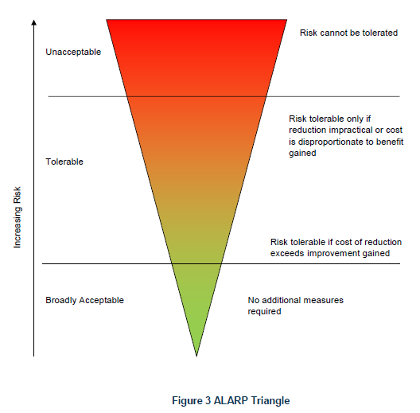

The SoS product was reviewed by the YHCR CSO and the NHS Digital Clinical Safety team. It has 3 main hazards – however these individual hazards have not been scored by the YHCR CSO as these are specific to each environment. The severity of the hazard cannot be scored as the severity will alter between sites/users. It is therefore the responsibility of the provider/consumer to evaluate the hazards based on their environment and uses of the system.

Generic hazards for the providers and consumers have been identified for use in their hazard log and are recorded in the master hazard log for consideration.

However each messaging type has been evaluated and scored accordingly.

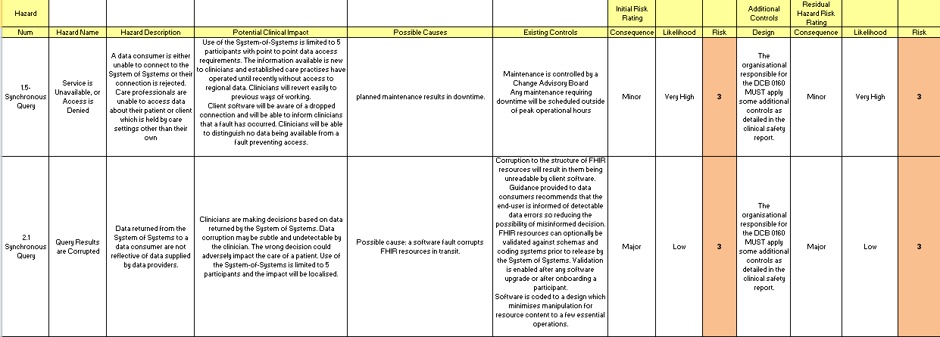

For Synchronous Query they are 6 hazards scored at low, 7 at medium and 2 at high. The 2 hazards which have a score of 3 still remain at that score as no further mitigations can be applied by the YHCR programme therefore the end user must review these hazards and apply internal mitigations to lower the score.

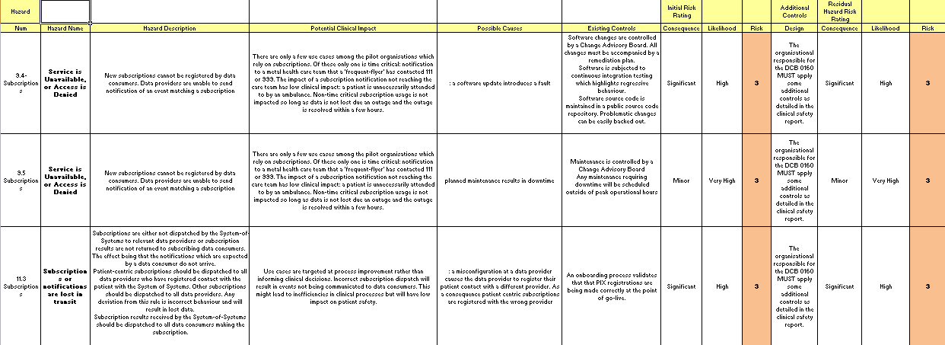

Subscriptions messages have 4 hazards scored at low, 11 medium and 3 at high. The 3 high scoring hazards have been reviewed and further mitigations considered however the YHCR programme has implemented all mitigations possible therefore the end user must review these hazards and apply further mitigations.

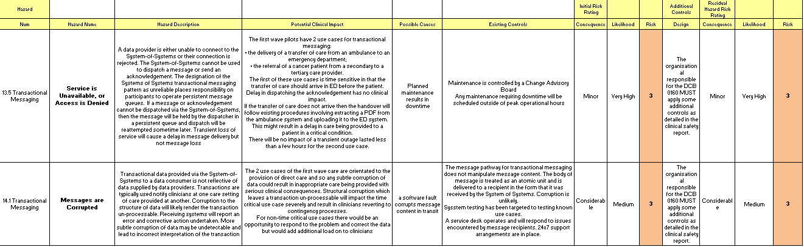

Transactional Messaging have 2 hazards scored at low 9 at medium 2 at high. Finally the 2 hazards identified have again been evaluated and the YHCR programme cannot apply any further mitigations, the end user must review the hazards and apply further mitigations to reduce the risk score.

GP Connect hazards were considered and scored 2 and below, these are detailed in the full hazard log, the NHS Digital Hazard log is also available for consuming organisations (ref 5) however for the latest up to date hazard log and guidance this should be requested directly from NHS Digital.

**Please see the whole Hazard log for full details (ref 4)**

## Technical / Cyber

Technical Assessments have been/will be performed prior to testing from data provider’s, data consumer’s and SoS perspective.

Each site which is or will be onboard has/will align their configuration with specific FHIR categories that are aligned to the Professional Records Standards Body. Each of these components will be subject to assurance of the technical solutions, that is each end point and organisation will need to have their Software Solution Assured.

Various FHIR tests are performed to ensure the systems are compatible. Various testing from the sites involved have been performed by the technical architects throughout the project and any issues reported and recorded on JIRA.

The primary objectives of the assurance are:

1. to ensure YHCR receives from its suppliers solutions that are fit for purpose
2. that the overall solution is fit for purpose, e.g. scalable, resilient, performant etc.

A FHIR resource database has been developed by the YHCR which details the mandated and nice to have fields for each resource type. The below document is still evolving however provides an idea of the FHIR database expected to be included in the YHCR SoS product.



**The Cyber Security Framework**

This provides a structure and reference to how Cyber Security will be applied and measured against appropriate security standards, e.g.

* UK Gov - Cyber Essentials scheme
* UK Gov - NIS Regulation (the technical side of GDPR)
* NHS Digital - Data Security and Protection Toolkit (DSPToolkit)

These standards ensure that appropriate and auditable security is applied and reportable.

## Service Management & Incident Reporting

Service management will be performed by the Rotherham Service Desk in the first instance and then once hosted by Google Cloud this will transition to local 1st line support. Synanetics will provide "early life " support, until the strategic service is enabled sometime in 2021. The slides provided show the current process and the transition planned for 2021. (This is subject to change).



Any incidents that arise from live service are triaged to local service desks and then on to the YHCR team, these incidents are actioned and other users informed via communication channels if affected. Incidents are logged at [ICR Live Support - YHCR Service Desk (atlassian.net)](https://yhcrservice.atlassian.net/browse/ICR) and any potential clinical safety incidents sent to the YHCR CSO. Depending on the incident a number of actions may be taken, these include but are not exhaustive:

* A fix to be made to the system
* Investigation into the issue locally
* Investigation performed regionally
* Communication sent to all users whom may be affected
* Review of incident at team meeting
* YHCR CSO review with other CSO in region
* Programme team manage with developers
* Hazard log reviewed to ascertain if initially identified

A clinical safety incident process has been created and is currently been implemented into the YHCR process. Please see detail in the document below.



# 

# Test Strategy

The YHCR programme has a robust testing strategy and assigned test manager. In essence the test manager engages with the end users and performs a series of testing. These tests vary between providers and consumers depending on the data resource types been provided/consumed.

Once User Acceptance Testing (UAT) has been completed a test report is produced which highlights any issues. These are reviewed and any issues agreed to be fixed and a timeline assigned. Daily/weekly calls are initiated between all parties to ensure durability and efficiently.

Several further testing sessions may take place before the UAT is signed off. The UAT is performed in the sandpit environment. They may be occurrences when the issue log is reviewed by the CSO at this point to determine if an issue needs be fixed before moving on to the next stage.

The test manager and YHCR CSO work closely together to identify, monitor and evaluate any issues and the testing.

Once complete the CSO engages with the end user CSO and performs a series of clinical witness testing in the sandpit environment. Once happy and clinically signed off, testing is moved to the staging environment.

Once in staging further tests are performed similar to that in the sandpit environment. No further issues should be detected at this stage however it can happen and therefore the test managers and CSO’s work together to ensure these are fixed and safe before proceeding.

The test reports are reviewed by the CSO and then a ‘Go-Live’ meeting is scheduled with the parties involved.

Once Go-Live is approved and a date set the provider/consumer is connected to the SoS.

On the day further testing is performed by the CSO and Clinician at the end site to ensure information is flowing correctly and safely in the production environment. After the initial one day assessment the service continues and is monitored in early life.

With regards to GP Connect robust testing has been driven by NHS Digital in the form of conformance testing. The test team have tested GP Connect as directed by the document set and provided evidence to the level directed by NHS Digital.

On boarding partner organisations that wish to connect and gain access to ‘view’ data, will engage directly with NHS Digital and will undergo the same conformance testing.  The test team will support the on-boarding organisations in aiding them to complete this testing

The diagram below outlines the various testing and live environments



# 

# Summary Safety Statement

This clinical safety report gives detail of the SoS product and the use of this middleware component for the YHCR programme. It also details the use and concept of SoS for the integrated shared care records for patients. It proves how the data flows through one system into the SoS and to the end user using various messaging types. The infrastructure is shown and hazards identified and mitigated to reduce any risks to the patient. It provides and evidences the level of assurance performed by the YHCR programme team and input from across the region. This includes:

* Information governance arrangements for the sharing of personal data in regards to direct care.
* The cyber security assurance process and technical assessments
* The FHIR resource tests created by Synanetics
* Synanetics having their own assurance processes as a third party middleware integrator.
* The test strategy and governance arrangements.
* The service management which is in place for incident reporting and escalation.
* All the assurance gateways feed into clinical safety and it is believed the release of SoS does not introduce any new known defects to the applications to end users or greater risk to patients in the application of clinical practice through live functionality.

Any users of the YHCR SoS sites should engage with in house clinicians and the YHCR programme team as well as their own project team to ensure clinical safety activities are performed. They are responsible for their own Hazard log and Clinical Safety Report DCB 0160.

# Appendices

# Appendix 1

**Hazard Consequence definitions**

| **Consequence Classification** | **Interpretation** | **Number of Patients Affected** |
| --- | --- | --- |
| Catastrophic | Death | Multiple |
| Permanent life-changing incapacity and any condition for which the prognosis is death or permanent life-changing incapacity; severe injury or severe incapacity from which recovery is not expected in the short term | Multiple |
| Major | Death | Single |
| Permanent life-changing incapacity and any condition for which the prognosis is death or permanent life-changing incapacity; severe injury or severe incapacity from which recovery is not expected in the short term | Single |
| Severe injury or severe incapacity from which recovery is expected in the short term | Multiple |
| Severe psychological trauma | Multiple |
| Considerable | Severe injury or severe incapacity from which recovery is expected in the short term | Single |
| Severe psychological trauma | Single |
| Minor injury or injuries from which recovery is not expected in the short term. | Multiple |
| Significant psychological trauma. | Multiple |
| Significant | Minor injury or injuries from which recovery is not expected in the short term. | Single |
| Significant psychological trauma | Single |
| Minor injury from which recovery is expected in the short term | Multiple |
| Minor psychological upset; inconvenience | Multiple |
| Minor | Minor injury from which recovery is expected in the short term; minor psychological upset; inconvenience; any negligible severity | Single |

# Appendix 2

|  |  |
| --- | --- |
| **Likelihood Category** | **Interpretation** |
| Very high | Certain or almost certain; highly likely to occur |
| High | Not certain but very possible; reasonably expected to occur in the majority of cases |
| Medium | Possible |
| Low | Could occur but in the great majority of occasions will not |
| Very low | Negligible or nearly negligible possibility of occurring |

# Appendix 3

|  |  |  |  |  |  |  |
| --- | --- | --- | --- | --- | --- | --- |
| **Likelihood** | Very High | 3 | 4 | 4 | 5 | 5 |
| High | 2 | 3 | 3 | 4 | 5 |
| Medium | 2 | 2 | 3 | 3 | 4 |
| Low | 1 | 2 | 2 | 3 | 4 |
| Very Low | 1 | 1 | 2 | 2 | 3 |
|  |  | Minor | Significant | Considerable | Major | Catastrophic |
|  |  | **Severity** | | | | |

# Appendix 4

|  |  |
| --- | --- |
| 5 | Unacceptable level of risk |
| 4 | Mandatory elimination of hazard or addition of control measure to reduce risk to an acceptable level |
| 3 | Undesirable level of risk. Attempts should be made to eliminate the hazard or implement control measures to reduce risk to an acceptable level. Shall only be acceptable when further risk reduction is impractical |
| 2 | Acceptable where cost of further reduction outweighs benefits gained or where further risk reduction is impractical |
| 1 | Acceptable, no further action required |

## Appendix 5



Initial Clinical Safety Report for Wave 1 sites